

Publications can be approved by anyone in Health, Disability and Ageing with the Publication Publisher role in the Data Portal.
To approve a publication in the Data Portal:
- Open the Data Portal through Health Data Portal.
- Log in using the information provided in the Register for and Log in to the Health Data Portal QRG.
The Data Portal home screen will display.
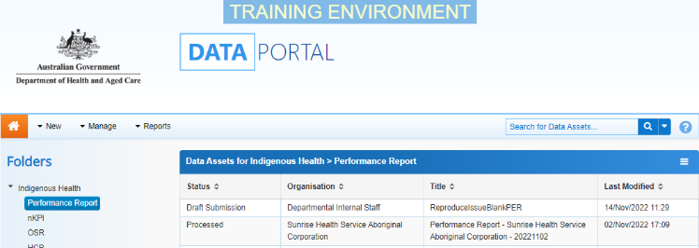
- From the Data Portal home screen, search for the publication to be approved.
For more information on how to search for a publication, see the Get Started in the Health Data Portal QRG.
 To be eligible for approval, the publication’s status will need to be Ready for Approval.
- Select the publication to be approved.
The Department of Health Publication screen will display.
- To update the details of the publication, select at the top of the screen.
The screen will update so active (white) fields on the screen can be edited if needed.
- Make any required amendments to the information on the Department of Health Publication screen.
- To review the contents of the attached file, select the file title link under File Name in the Files section.
- There are several actions that can be performed on the attached file, in the Files section, if needed.
Button | Description
 | Select this button under File Name to download and view the file. A pop up will appear in the top right-hand corner of the screen and you can open the file from here and save it as required.
 | Select this button under File Name to replace the file with another file if you have uploaded it incorrectly.
 | Select this button under Actions to view the file’s previous versions.
 | Select this button under Actions to add text to the Description field.
 | Select this button under Actions to remove the file from the publication.
 | Select this button under Actions to view the file’s download history.
 | Select this button under Actions to see a list of users who will have the required file permissions to view the file once the publication is published.
Select this button under Actions to add an updated version of the file if needed.
This will just add a second file, rather than replace the existing one.
- To save your changes to the publication, select .
- Once the publication and the attached file have been reviewed as required, select either or the workflow progress bar at the top of the screen and, in the Change Data Asset Status window, in the Action field, select and select the required action.
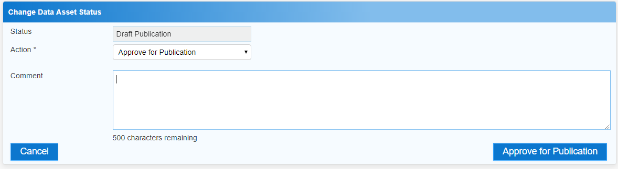
The available actions are:
- Revision Required – Select this action if the publication needs to be returned to the Publication Producer for amendment.
- Approve for Publication – Select this action to approve the publication and progress it to the status of Approved for Future Publication (if the publication period is not yet active) or Published (if the publication period is active).
Approve a Publication
- In the Comment field, add any comments regarding the publication if required.
- One of the following options can now be selected, depending on the action you have selected:
  - To send the publication back to the Publication Producer for amendment, select . See the Amend a Draft Publication QRG for the next step in the process.
  - To approve the publication and send it for publication, select . See the Work with Approved Publications QRG for the next step in the process.
- To save the publication as a draft without sending it on to the next stage of the publication process, select .

The publication has now been approved for publishing and will be published for viewing and downloading as soon as the publishing start date is reached.

